***Table of Contents***

Document Information 2

Definition of Terms, Acronyms, and Abbreviations 2

Table of Contents 3

1 Introduction

1.1 Problem Statement 4

1.2 Ai Driven Features For Business Management Tool 6  
 1.2 Product Position Statement 7  
 1.3 Project Motivation and Background 7  
 1.4 Objectives 8  
 1.5 Sustainable Development Goal 8

1.6 Functions 9

1.7 SubProjects 9

2 Background and Literature Review

2.1 Introduction 11

2.2 Gaps in Current Knowledge 11

2.3 Similar Application  11

2.3.1 Zoho 12

2.3.2 PakERP 12

2.3.3 Limitations of Existing Solution  13

3 Project Scope

3.1 In Scope 13

3.2 Out of Scope 14

4 Proposed Methodology

4.1 SDLC Approach (Waterfall/Agile/Spiral) 15

4.2 Requirement Development Methodology 15

4.2.1 Data Collection 15

4.2.2 Analysis and design 16

4.2.3 System Diagram 17

4.2.4 Actor Use Case Diagram 17

4,3 Development and implementation 19

5 Project Requirements 19

6.1 Software tools requirements 20

6.2 Hardware requirements 21

21

7 Project Deliverables (you may change according to your project methodology) 21

8.1 Phase I - Alpha Prototype 21

8.2 Phase II - Beta Prototype 21

8.3 Phase III - Release Candidate 22

8.4 Phase IV - Final Product 22

11 References 22

*1* *Introduction*

* 1. ***Problem Statement***

Small businesses often struggle with managing various aspects of their operations, such as sales, billing, payments, invoicing, inventory management system and reporting, due to a lack of user-friendly, customizable management tools.

Common problems faced are:

### ****Sales Management Challenges****

* **Inefficient Sales Tracking**: Many businesses rely on spreadsheets or separate tools that do not integrate well, leading to manual errors and inefficiencies.
* **Lead Prioritization Issues**: Without AI-driven lead scoring, sales teams struggle to identify high-converting opportunities.
* **Customer Data Disorganization**: Difficulty in tracking past interactions and sales transactions prevents effective relationship management and customer retention.

### ****Billing and Payment Delays****

* **Manual Invoicing Errors**: Creating invoices manually increases the chances of errors, late payments, and discrepancies.
* **Unpredictable Cash Flow**: Late payments from clients are a significant concern, and businesses often lack tools to forecast and manage cash flow.
* **Limited Integration across Platforms**: Invoicing tools not integrated with sales or purchase modules can result in inconsistent financial reporting.

1. **Inventory Management Errors**

* **Manual Inventory Tracking Issues**: SMBs in manufacturing, retail, and distribution struggle to **accurately manage stock levels** and product orders.
  + **Impact**: Inefficient inventory tracking leads to **overstocking, stockouts**, and ultimately, lost revenue opportunities

### 4. ****User Accessibility and Technical Expertise****

* **Limited IT Staff**: Many SMBs do not have dedicated IT teams, and employees with technical expertise may be scarce.
  + **Impact**: Implementing and maintaining complex software solutions becomes difficult, often requiring **external consultants**, which increases costs.
* **Steep Learning Curves**: Even advanced business tools often require **extensive training**, which is a barrier for non-technical employees

### ****Lack of Data Analytics and Insights****

* **No Predictive Analytics Tools**: SMBs often do not have access to tools that can **analyze business trends, forecast sales, or predict customer behaviors**.
  + **Impact**: This leads to poor decision-making and missed opportunities for growth and market expansion.
* **Manual Reporting Issues**: Generating business reports requires a significant amount of **manual effort and time,** which takes away focus from core business activities.

### ****Security Concerns****

* **Data Privacy Risks**: Many SMBs use multiple cloud-based tools and face issues with fragmented security protocols.

**Lack of Robust Backup Solutions**: A failure to implement solid cloud storage solutions increases risks of data loss

Many existing solutions are either too complex or do not provide the flexibility needed for businesses to adapt to their unique needs. This results in inefficiencies, increased risk of errors, and difficulty in tracking business performance.

To address these issues, there is a need for a **Business Management Tool Maker**, a Software-as-a-Service (SaaS) platform that allows small businesses to create and manage their own tailored management tools. This platform will streamline operations, secure data handling, and enhance overall productivity by offering customizable modules for sales, billing, payments, invoicing and reporting.

Additionally, integrating AI will further enhance the platform's capabilities, improving decision-making, operational efficiency, and user experience.

* 1. ***AI Driven Features for Business Management Tool***

### ****Predictive Analytics****

AI helps predict future business trends like sales, employee turnover, or customer behavior. This lets businesses plan ahead, avoid problems, and improve operations.

**How Tackled**: AI analyzes past data to predict future needs, such as sales or staffing, helping business owners make better decisions.

### ****Sales Forecasting for Products****

AI can predict which products are likely to sell more during a specific season or time of the year based on past sales data. This helps businesses plan inventory, promotions, and sales strategies more effectively.

**How Tackled**: By analyzing historical sales patterns, AI can forecast demand for products during different seasons or special events, allowing businesses to stock up on high-demand items and avoid overstocking products with lower sales potential.

### ****Lead Scoring and Prioritization****

AI can analyze customer data and predict which leads are most likely to convert into sales. By identifying the most promising leads, sales teams can prioritize their efforts, increasing efficiency and closing rates.

**How Tackled**: AI uses customer behavior, demographics, and past interactions to score leads, helping sales teams focus on those with the highest likelihood of converting.

### ****Intelligent Billing and Payments****

AI automates invoicing, sends reminders for overdue payments, and can predict payment delays based on customer behavior, improving cash flow.

**How Tackled**: AI generates invoices, tracks payments, and sends reminders. It also helps businesses identify clients who might delay payments, so they can follow up in advance.

* 1. ***Product Position Statement:***

The **Business Management Tool Maker** is a cloud-based SaaS platform designed specifically for small businesses that wish to automate and simplify their operational processes. Unlike traditional off-the-shelf business management software, this platform offers highly customizable features, including sales tracking, billing automation, payment processing, reporting, HR management, inventory management and invoice management. It empowers business owners, managers, and employees to create personalized solutions that best suit their specific needs, without requiring advanced technical skills. With a focus on ease of use, flexibility, and data security, the **Business Management Tool Maker** stands as a reliable, scalable, and cost-effective solution for businesses looking to streamline their operations and maintain control over their business data.

It also uses **Artificial intelligence** to make smarter business decisions by predicting trends, suggesting actions, and automating tasks like invoicing, payroll, and reporting.

* 1. ***Project Motivation and Background:***

The rapid expansion of small and medium-sized businesses (SMBs) in recent years has fueled the demand for efficient and customizable management tools. SMBs often face challenges in integrating advanced business solutions, primarily due to high costs and lack of flexibility in off-the-shelf software. Traditional business tools do not always meet the unique requirements of smaller businesses, leading to the development of customizable platforms that can be tailored to specific business operations. The Business Management Tool Maker project aims to address this need by providing a customizable, cloud-based Software-as-a-Service (SaaS) platform to streamline SMB operations.

* 1. ***Objectives:***

• **Develop a Customizable Business Management Tool**:  
To create a cloud-based platform that allows small and medium-sized businesses (SMBs) to design and customize their own business management tools (such as sales tracking, billing, payment processing, and invoice management) according to their specific needs.

**Incorporate AI for Smarter Decision-Making and Automation:**  
To integrate AI-driven features that help businesses predict trends, automate tasks, and provide actionable insights. AI will be used to forecast sales, optimize pricing, recommend actions for improving efficiency, and personalize the user experience for each stakeholder.

**Provide an Affordable Solution for SMBs**:  
To offer a cost-effective business management platform that is more accessible to SMBs, providing flexible pricing models and minimizing the need for expensive, complex software solutions.

**Ensure Ease of Use for Non-Technical Users**:  
To design a user-friendly interface with a drag-and-drop functionality, enabling business owners and employees to create and manage business tools without needing technical expertise.

**Offer Flexibility for Different Stakeholders**:  
To support various user roles (business owners, managers, employees) by providing role-based access control and customizable dashboards to suit each user’s needs.

* 1. ***Sustainable Development Goals (SDGs):***

The project supports the **Sustainable Development Goals (SDGs)**, specifically:

* **SDG 8: Decent Work and Economic Growth**
* **SDG 9: Industry, Innovation, and Infrastructure**

By offering affordable, accessible, and scalable tools for small and medium-sized businesses (SMBs), the platform helps promote **economic growth** and **innovation**. It enables SMBs to improve productivity, stay competitive, and grow sustainably. With features like **HR management**, businesses can also streamline employee management, track performance, and ensure fair and efficient work practices, contributing to better jobs and workplace conditions. Overall, this platform helps SMBs drive economic development and foster long-term success

* 1. ***Functions:***

The key functionalities of Business Management Tool Maker are described below:

1. **Manage Sales**: This module allows businesses to record, track, and manage sales transactions. It helps in maintaining sales data, generating receipts, and updating inventories in real time.
2. **Manage Purchases**: This functionality manages the entire purchasing process, including creating purchase orders, tracking supplier payments, and updating stock levels.
3. **Generate Invoices**: The platform automates the process of creating invoices for clients, which helps in improving accuracy and efficiency while ensuring timely payments.
4. **Bill Management:** This feature supports tracking and managing bills, including vendor payments, outstanding dues, and payment scheduling.
5. **Inventory Management System:**

The IMS module provides real-time tracking of stock levels, product orders, and inventory movements. It automates stock updates with each sale or purchase, ensures timely reordering, and helps prevent stockouts or overstocking. Businesses can set alerts for low stock, track inventory across multiple locations, and generate reports on product performance. Integration with the sales and purchase modules ensures accurate inventory levels, improving decision-making and operational efficiency

1. **Reporting & Analytics:** The platform provides real-time reporting and analytics, offering businesses insights into key metrics like sales, purchases, invoicing, and HR performance. Customizable reports help businesses track performance, make data-driven decisions, and improve overall operations.
2. **AI-Powered Insights and Automation:**  
   This feature uses AI to make your business smarter and more efficient. It helps predict trends, automate tasks like sales forecasting and invoicing, and gives suggestions to improve operations. AI also analyzes your data and provides personalized recommendations, helping you make better decisions and save time.
   1. ***Subprojects:***

The project is divided into several subprojects to ensure focused development in each area:

1. **Platform Development** - focuses on creating the drag-and-drop tool interface.
2. **Database Management** - ensures the system can handle large volumes of business data securely.
3. **AI Integration** – focuses on adding AI features like smart recommendations, data analysis, or automation to the platform

# 2 *Background and Literature Review*:

## Introduction:

The rapid growth of small and medium-sized businesses (SMBs) in recent years has increased the need for efficient and customizable management tools. However, many SMBs struggle to find solutions that are both affordable and flexible. Traditional business software can be expensive and often doesn’t fit the unique needs of smaller businesses. As a result, there is a growing demand for customizable platforms that can be adjusted to different business operations.

The **Business Management Tool Maker** project aims to solve this problem by offering a **Software-as-a-Service (SaaS)** platform that is easy to customize and helps SMBs streamline their operations. This platform provides tools for sales, billing, payments, invoicing, HR management, and reporting, all in one place.

## Gaps in current knowledge:

Current research highlights a significant gap in business management tools designed specifically for **non-retail SMBs**. Most available platforms are tailored to retail and service industries, overlooking sectors like **manufacturing, healthcare**, and **education**. The **Business Management Tool Maker** platform aims to fill this gap by offering a highly customizable and affordable solution that works for businesses across various industries, not just retail.

Furthermore, while low-code platforms are becoming more popular, few solutions integrate advanced technologies like **Machine Learning (ML)** and **Natural Language Processing (NLP)** to help businesses customize their management tools. The Business Management Tool Maker platform plans to bridge this gap by combining these advanced features with an easy-to-use interface, allowing businesses to create more intelligent, adaptable tools that meet their specific needs without requiring deep technical expertise.

## Similar Applications:

Several business management tools are currently available on the market, aimed at helping companies manage their daily operations more effectively. Below are some notable examples:

### Zoho:

**Source**: **Zoho** is a comprehensive suite of online productivity tools and SaaS applications designed to streamline business operations.

**Main Features**: Wide range of integrated tools across CRM, marketing, finance, HR, and project management. High-level security measures, including data encryption and compliance with global standards. Real-time data access and collaboration capabilities from anywhere. Robust customer support and extensive troubleshooting resources.

**Deployment Strategies**: Cloud-based platform accessible from any device. Offers a unified platform that integrates various business functions like CRM, marketing, finance, HR, and project management to streamline operations.

**Cost**: Offers different pricing tiers, but some businesses find the costs for comprehensive packages high, particularly if they only need a limited set of features. Additional costs for more advanced HR and reporting tools or when opting for larger, more complex suites.

**Technical Interface**: Pre-built features that cannot be fully customized. Some users report challenges in setting up and maintaining third-party integrations, especially with non-Zoho software. Complex system that can overwhelm small business owners, particularly those without technical expertise.

**PakERP:**

#### ****Source****:

PakERP is a local ERP solution in Pakistan that supports small and medium-sized businesses. It helps manage inventory, finances, and procurement processes.

#### ****Main Features****:

* **Inventory Management**: Tracks stock, alerts for low inventory, and handles batch numbers.
* **Procurement**: Simplifies vendor management and purchase orders.
* **Finance Tools**: Handles accounts payable and receivable, tax calculations, and financial reporting.
* **Industry-Specific Options**: Custom modules for industries like manufacturing and retail.

#### ****Deployment Strategies****:

* Mostly installed on **local servers**, with limited cloud access.
* Gives businesses control over their data but can be harder to access remotely.

#### ****Cost****:

* Upfront payment is required for installation and setup.
* Maintenance and upgrades can cost extra, making it less flexible compared to subscription-based platforms

#### ****Technical Interface****:

* **Fixed workflows** that are hard to change for unique business needs.
* Can be **difficult to use without training**.
* Limited options for connecting with other software.

Our solution stands out by offering a **customizable**, **affordable**, and **user-friendly** platform that integrates key business functions such invoicing, and reporting, specifically designed for small businesses. It addresses the limitations of both **Zoho** and **Pakerp** offering a simpler, more accessible alternative while maintaining scalability and security, making it a compelling option for businesses, especially in regions like Pakistan.

### Limitations of Existing Solution:

Although the existing business management tools are sophisticated, they fall short in several areas:

1. **Customization:**

Many tools offer rigid structures, meaning businesses have to adapt their operations to the platform rather than the other way around.

1. **Cost:**

High subscription fees and implementation costs make these solutions prohibitive for small businesses.

1. **Complexity**:

The user interfaces of many platforms require significant training, which can be a barrier for SMBs with limited technical resources.

**3 Project Scope:**

The project will focus on developing a SaaS platform that enables SMBs to construct tailored business management solutions through a user-friendly drag-and-drop interface. By incorporating AI-driven suggestions and automation, the platform will streamline business operations and reduce reliance on technical expertise.

…………..

**3.1 In Scope:**

**Drag-and-Drop Interface**:

* Development of a user-friendly drag-and-drop interface that allows SMBs to design and customize their own business management tools (sales, invoicing, billing, payments) without needing technical expertise.
* **AI-Powered Insights:**  
   The platform will integrate AI to analyze business data, predict trends (such as sales forecasts or customer behavior), and provide actionable insights to help businesses make informed decisions and optimize operations.

**Customizable Business Management Tools**:

* Tools for managing sales, invoicing, payments, and other business functions, which users can tailor according to their specific requirements.

**Automated Reporting and Analytics**:

* Providing businesses with real-time reporting and analytics tools to track sales, invoices, payments, and other metrics, with the ability to export reports.

**Data Protection and Cloud Backup:**

To ensure business continuity, the platform offers secure cloud-based storage and backup, safeguarding sensitive business data and protecting it from unauthorized access

**Inventory Management System (IMS)**:

The platform will include an inventory management system to track stock levels, product orders, and inventory movements in real time. It will automate stock updates with each sale or purchase, ensure timely reordering, and prevent stockouts or overstocking. Businesses will be able to set up alerts for low stock, manage inventory across multiple locations, and generate reports on product performance..

**3.2 Out of Scope:**

**E-commerce Solutions**:

* The platform will not include e-commerce functionality (such as product catalogs, shopping carts, or payment gateways for online stores), as the focus is on business management tools rather than online retail.

**Enterprise-Level Functionality**:

* The platform is specifically designed for SMBs, not large enterprises, so features meant for complex multi-department or multi-national operations will be excluded.

**Mobile Application Development**:

* The platform will not focus on developing native mobile apps for iOS or Android, though it may be mobile-responsive.

.

.

.

**4 *Hardware, Software analysis and requirements***:

**4.1 SDLC Approach (Waterfall/Agile/Spiral):**

The project will adopt the **Agile methodology** due to its flexibility and iterative nature, which suits the needs of this SaaS platform. Given that SMBs may provide ongoing feedback, Agile enables continuous improvement through short development cycles (sprints). Each sprint will focus on building and refining features such as the drag-and-drop interface, customizable tools, and AI-driven suggestions.

Key Agile benefits for this project:

**Iterative Improvements**: Allows for regular updates and improvements based on user feedback.

**Adaptability**: Enables quick adjustments as new requirements emerge.

**User-Centric**: Frequent user feedback aligns the platform with actual SMB needs.

………..

**4.2 *Requirement Development Methodology:***

**Data Collection:**

To ensure that the platform meets the unique needs of SMBs, data collection will be conducted through a combination of methods:

**Interviews**: Conducted with business managers and employees to understand their needs for managing sales, billing, invoices, and payments.

**Observation**: Observed current business processes to identify areas of inefficiency or error.

**Document Analysis**: Reviewing existing documentation and solutions for similar business management tools to understand market needs and trends.

**Analysis and Design:**

## Overall System Structure:

### *System Diagram*

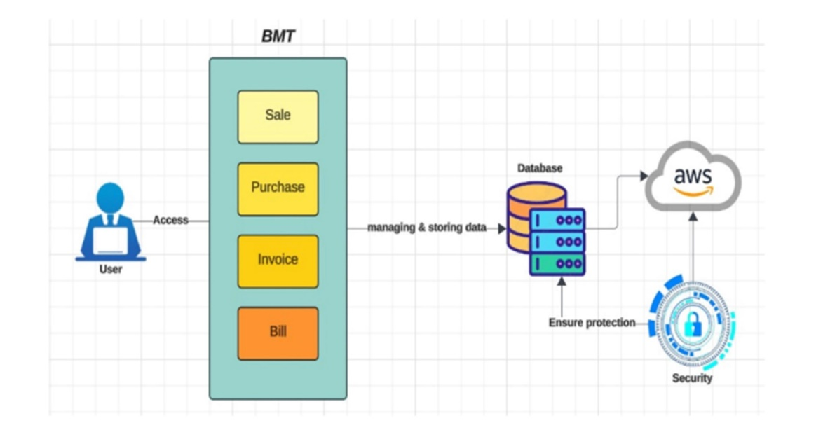

Figure 2: System Diagram

***Description:***

The above diagram explains the Business Management Tool system which is used to automate and streamline daily business operations such as managing sales, purchases, invoices & bills etc. using a single platform for all these processes. Fundamental to that is the user interface for recording sales transactions and generation invoices, managing billing activities etc. The Business Management Tool System data is saved in a sustainable and safe AWS database which protects the efficiency of managing your information. To safeguard the integrity, confidentiality and availability of sensitive information, high security standards are integrated at different stages which contain strong security measures within its framework. The Business Management Tool is an all-in-one tool for companies of any size that streamlines operations, brings about efficiency and offers a unified platform to manage critical processes.

### *Actor Use Case Diagram*:

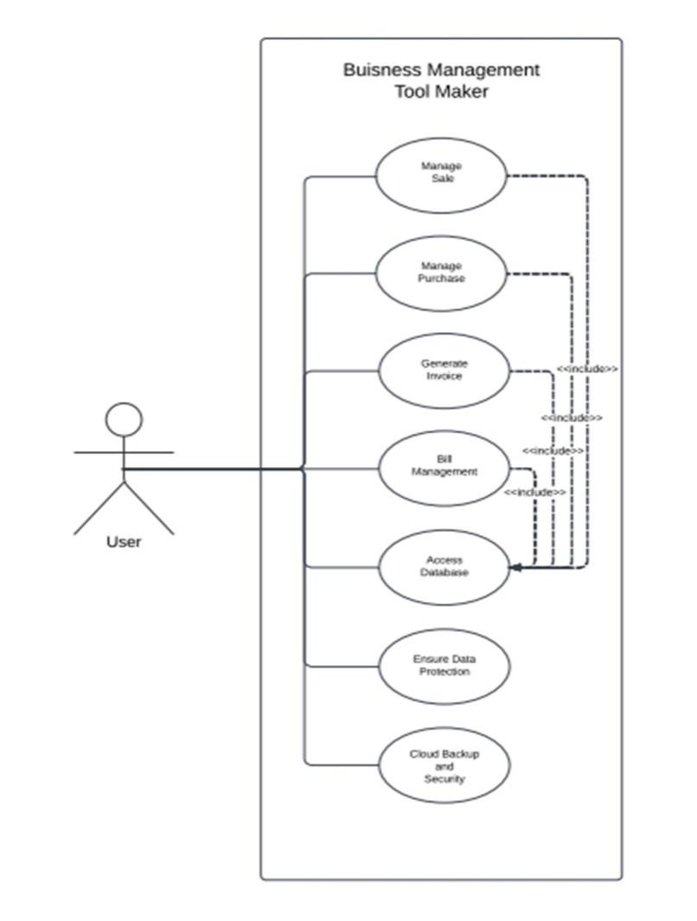

Figure 3: Actor use Case Diagram

***Description:***

Business Management Tool Maker Use case diagram A use case of a Business Management Tool Maker system designed to help users manage their different business processes (sales, purchases, invoices and billing) efficiently. At the heart of this system is a user interface, through which users can access various modules and interact with an extensive database to facilitate data management/recovery. The system implements strong data protection measures to secure sensitive information and comes with industry-standard practices for protecting the integrity, confidentiality, and availability of your Data. Moreover, it includes cloud backup for redundancy and data loss prevention to maintain business continuity. In the end, this system simplifies complicated operations that operate under a simple level of complexity and guides users to become more effective in their operation processes by making conscious decisions.

### *Activity Diagram:*

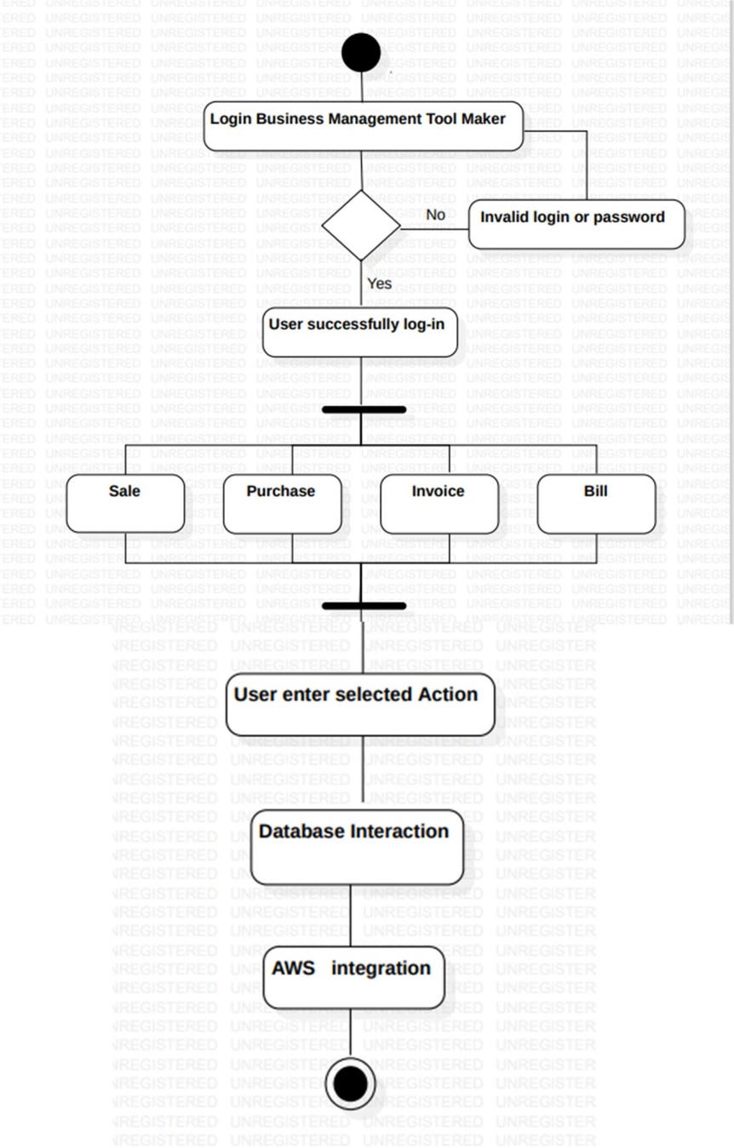

Figure 4: Activity diagram

***Description:***

The activity diagram illustrates the workflow within a Business Management Tool Maker system, starting with a user attempting to log in. If the credentials are valid, the user gains access and is presented with a menu of options for managing sales, purchases, invoices, and bills. The user can select any option based on their needs. Once an action is chosen, the system interacts with the database to retrieve, update, or store relevant data. It may also integrate with external services like AWS for additional functionalities, such as data storage or analysis. This process continues until the user completes their desired action or chooses to log out, outlining the key activities and their sequence in using the Business Management Tool Maker.

***4.3*** ***Development and Implementation:***

**Development Phases**:

**Frontend Development**: Created a user-friendly interface with drag-and-drop functionality, allowing SMB users to customize and organize their business tools without technical expertise.

**Backend Development**: Implemented features for sales management, invoice generation, payment processing, inventory and automated billing. AI-based features were also developed to provide relevant suggestions for users, simplifying their workflow.

**Database Integration**: Configured a MySQL database to store and manage business data securely, with encryption protocols and integrity checks to ensure data security and accuracy.

**AI Integration** – focuses on incorporating artificial intelligence features into the platform. This may include developing machine learning models, natural language processing capabilities, predictive analytics, or automated decision-making processes, depending on the specific needs of the project.

**Implementation**

**Version Control and Collaboration**: **Git** is used to track changes and manage code versions, allowing seamless collaboration among team members and ensuring that updates are synchronized across the tea.

**6 *Project Requirements:***

**6.1 Software tools requirements:**

## Comparison of Software Technologies

**Front-End:**

* HTML/CSS/JavaScript: Standard technologies for building responsive web interfaces.
* React or Angular could be alternatives for a modern, dynamic UI.

**Back-End:**

* Python: Known for their flexibility, rapid development, and strong community support.
* Node.js: Could offer faster I/O operations but lacks the robustness of Python frameworks for handling complex logic.

**Database:**

* MySQL vs. Oracle: MySQL is open-source and widely supported, while Oracle is more powerful but complex and costly.
* Choice: MySQL is chosen for its simplicity, widespread adoption, and costefficiency.

**Algorithms:**

* Natural Language Processing (NLP): For understanding user inputs.
* Machine Learning: For recommending templates and analyzing patterns in user inputs.
* Choice: These algorithms enable smarter, personalized business management tools.

### *Front-End Comparison:*

**HTML/CSS/JS:** Chosen due to its simplicity and compatibility with a wide range of devices. It suits the project’s need for a responsive and user-friendly interface.

**React/Angular:** Not chosen, as these would be more appropriate for larger-scale, dynamic applications requiring highly interactive user interfaces. For a business management tool aimed at SMBs, this may add unnecessary complexity

**Back-End:** developed with Python: Known for their flexibility, rapid development, and strong community support.

**Node.js**: Could offer faster I/O operations but lacks the robustness of Python frameworks for handling complex logic.

**6.2 *Hardware requirements:***

**Specialized Hardware:** Google Cloud Platform (GCP), or Microsoft Azure will be employed for hosting the platform.

• The project will avoid on-premises servers or specialized physical hardware, focusing on cloud services for cost-efficiency and accessibility

**8 *Project Deliverables (you may change according to your project methodology):***

**8.1 Phase I - Alpha Prototype**  
A basic version with core features like drag-and-drop tool creation, sales and billing functions, and initial setup of the reporting. Initial testing of these core features.

**8.2 Phase II - Beta Prototype**  
Enhanced version with customization options, AI suggestions, and expanded inventory functions and reporting functions. User feedback will guide improvements for usability and functionality.

**8.3 Phase III - Release Candidate**  
A near-final version that’s feature-complete, including refined reporting and inventory capabilities. Final testing for stability and readiness.

**8.4 Phase IV - Final Product**  
The full SaaS platform, ready for SMBs, with complete sales, billing, reporting, inventory, and other key features.

***References:***

[1] A. Munir, L. Bengtsson, and E. Åkesson, "Management tools for business model innovation – a review," in *Management Tools*, 1st ed. New York, NY: Routledge, 2022, pp. 45-56. doi: 10.4324/9780429346033-11.ssss

[2] J. Mitchell et al., "SaaS in Business Management: A Comparative Study," *Journal of Cloud Computing and Business Processes*, vol. 8, no. 3, pp. 67-80, Mar. 2022.

[3] A. Ahmed and R. Roy, "Impact of CRM Systems on Customer Satisfaction," *Customer Relationship Management Review*, vol. 15, no. 2, pp. 22-30, Jan. 2021.

..